Week 8 Homework (30 pts)

1. Problem 1 (6 pts). Use ASPE to solve 13-7.2. You don’t need to do parts (a)-(c).

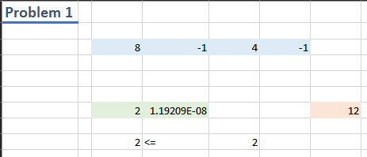

1. Problem 2 (6 pts). Do parts (a)-(c) of 13-7.6. Include a picture of the spreadsheet here (or paste the spreadsheet directly into the document) and describe any differences, if any, between the two solver approaches.

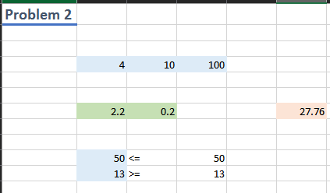

1. Problem 3 (6 pts). Use OPL to solve the quadratic program in problem 13.7-7. You do not need to do parts (a)-(d). Instead, include the OPL file here as well as the output. A sample quadratic program, qpex1.mod file from the IBM documentation, is included in the download packet. Alternately, you can install the qpex1 example in CPLEX Studio.

range R = 1..2;

dvar float x[R];

maximize

200\*x[1] - 100\*x[1]^2 + 300\*x[2] - 100\*x[2]^2;

subject to {

x[1] + x[2] <= 2;

}

// solution (optimal) with objective 312.49999990755

x = [0.75 1.25];

1. Problem 4 (6pts). As a warmup to next week do problem 13.10-5. We’ll learn more about multistart and evolutionary algorithms next week. Include spreadsheet (or image of spreadsheet) here. Did you notice any differences between the solvers?

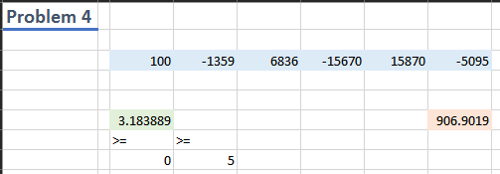

1. Problem 5 (6pts). Solve 13.1-2 using the GRG Solver in ASPE. This is an example of a convex objective function, but proving that is beyond our scope. You’ll have to formulate the profit function, but to give you an idea the profit due to selling x1 units of product 1 is (35+100 x1^(-1/3) ) \* x1 – 25 x1 … you fill in the rest.